Unlocking Insights into the Global Air Transportation Network with Tableau.

1. Introduction :

We analyze the global structure of the worldwide air transportation network, a critical infrastructure with an enormous impact on local, national, and international economies. We find that the worldwide air transportation network is a scale-free small-world network. In contrast to the prediction of scale-free network models, however, we find that the most connected cities are not necessarily the most central, resulting in anomalous values of the centrality. We demonstrate that these anomalies arise because of the multicommunity structure of the network.

In contrast to the prediction of scale-free network models, however, we find that the most connected cities are not necessarily the most central, resulting in anomalous values of the centrality. We demonstrate that these anomalies arise because of the multicommunity structure of the network.

1.1 Overview :

This Global Air Transportation Network dataset is a comprehensive collection of information on airports, airlines and their routes. It contains information such as names, cities, countries, codes (IATA and ICAO) longitudes, latitudes and altitudes of airports across the world with detailed time zone and daylight saving time data. Additionally, this includes information about airlines including their IDs, name aliases, IATA and ICAO codes, callsigns country of origin and active/inactive status. Similarly, it also covers route details such as airline sources to destination airports along with essential details like codeshare stakeholder if any stops required during this journey along with the type of aircraft being used for that particular journey. This dataset has been compiled through meticulous labor by researchers all over the world to give you a comprehensive detail into air transportation networks from around the globe.

1.2 Purpose :

Route planning is the process of designing and selecting the best routes for the flights in an air transportation company. Data analytics can help route planners analyze historical and real-time data on factors such as weather, traffic, fuel consumption, and customer preferences. Data analytics can also help route planners simulate and compare different scenarios and outcomes, and adjust their plans accordingly. By using data analytics, route planners can optimize the trade-offs between time, distance, cost, and customer satisfaction, and increase the profitability and performance of their flights.

2. Problem Definition & Design Thinking :

2.1 Empathy Map :

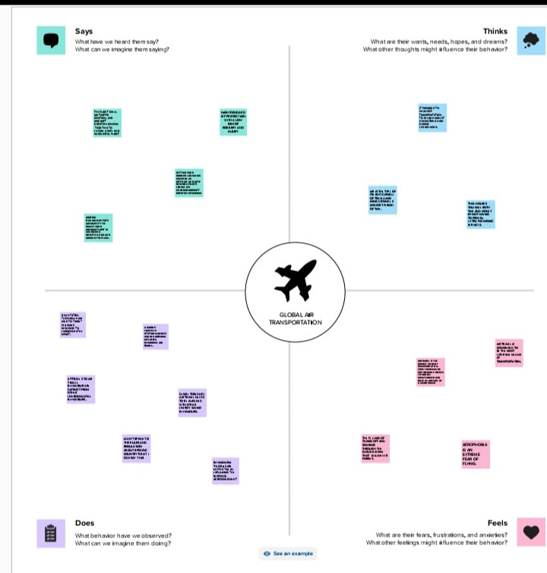

2.2 Ideation & Brainstorming Map :

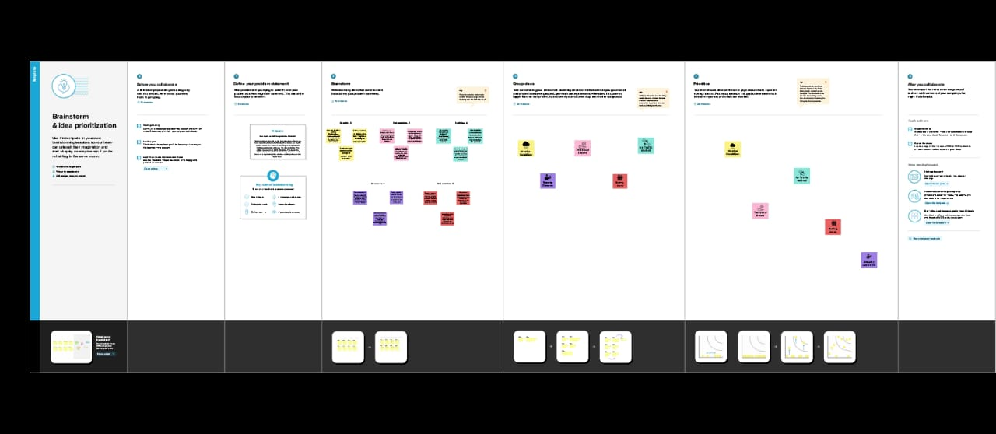

3. RESULT :

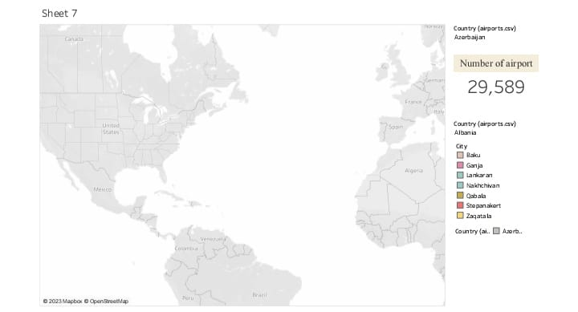

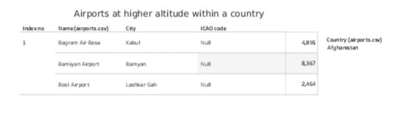

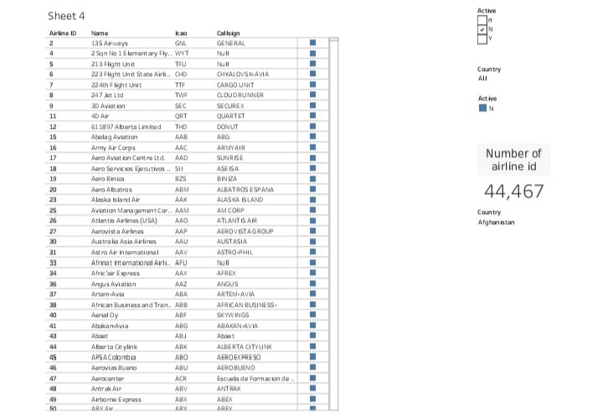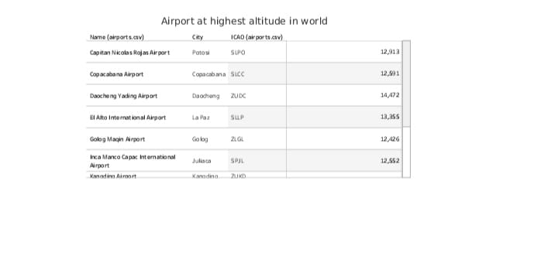

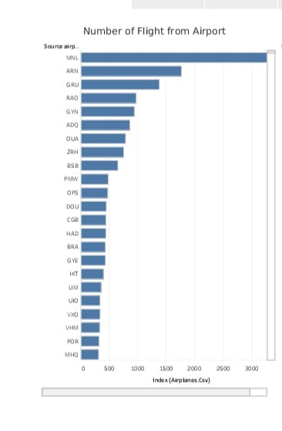

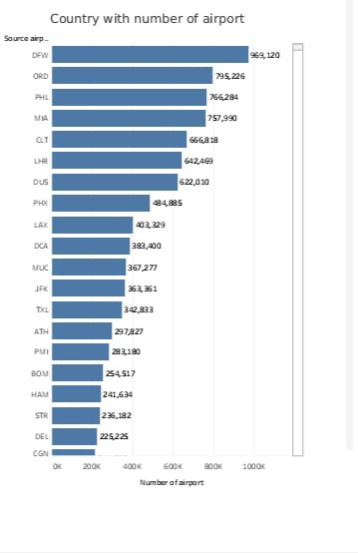

4. ADVANTAGES & DISADVANTAGES :

ADVANTAGES OF AIR TRANSPORTATION :

To understand the importance of air transport, its special characteristics must be taken into account. This overlooks a number of advantages that are very attractive and perfectly adapted to the specific needs of each company.

Characteristics of air transportation :

What are these advantages? Here are the important advantages of air transport Take note!

Fast delivery times :

Undoubtedly, one of the most advantageous features offered by air transport is its speedy delivery times.

There is no faster transport service than air transport. In addition, the frequency of flights makes delivery times very frequent and fast.

No Physical Limits :

Air transport is the only means of transportation that does not support physical limits. Road transport, for example, must undergo different physical constraints that slow down delivery times.

It is one of the means of transportation that offers practically no interruption in its services, which is very attractive for companies.

Very reliable transportation :

One of the great advantages of air transport for both passengers and goods is its great reliability.

Delays in delivery dates or loss of goods are options that can be very difficult to achieve with this means of transport.

Long Distances :

No other means of transport in the logistics sector can cover such long distances as air transport. This is a great advantage for international trade, being able to cover long distances, impossible for road or sea transport.

DISADVANTAGE OF AIR TRANSPORTATION :

Although the advantages of air transport are very attractive and define a totally unbeatable type of service, it is also possible to define a series of disadvantages that should be analyzed to determine whether air transport is appropriate or whether it is preferable to consider other types of transport, such as sea transport.

Higher Cost

There is no doubt that air transport is the least economical means of transportation compared to other types of transport.

The cost of infrastructure, fuel… makes air transport economically superior to other alternatives.

It is important to know how to analyze and calculate the economic and logistical performance to know if it is the ideal option to be used.

Less storage capacity

Storage capacity is lower than land and sea transport. This is a clear disadvantage, air transport is ideal for medium or low loads, but is not so attractive for large volumes of goods.

Restrictions on goods

Air transport, due to its specific characteristics, cannot carry certain products or goods. It suffers from certain restrictions, especially in liquid products such as petroleum, oils, etc…

5. Application :

For this project we use many of the application



We use more application to form data analysis from the database given in naan mudhalavan. For the empathy mapping and brainstorming we use mural for story of data analysis is formed by the help of tableau applications. We input the database which given by the naan mudhalavan is used to form the data analysis of air transportation network in tableau. We record the video to explain the data analysis. We make this record for the smart internz . By the help of this applications we express our creative are data analysis.

Conclusion :

A small summarize whether the experiment or survey results support or contradict the original hypothesis. By using mural application we form empathy mapping which is answer our creative. Says,things,does,feels about the global air transportation. We form brainstorming to define the problem in air transportation. Form our team each person’s find the individual problems and their solutions. We make that problems as the graph regarding to the problem. Then, we collect the database and upload in tableau application to form data analysis for that analysis we form eight sheets , four dashboard and story. Collection of sheets make dashboards and all the dashboard is used to form the story. In the sheets we can collect number airports in a country, number of airline Id in country, airport at highest altitude within a country , airport at highest altitude in world , number of flights from airport country with number of airport , in map we use to select the country and we can see the airport . The record the video to explain the data analysis of global air transportation.

Future scope :

India is currently the third largest aviation market in the world, with over 340 million passengers traveling by air annually in 20191. The industry has a number of domestic and international airlines, as well as a large network of airports. The future of the aviation industry in India is likely to see continued growth and expansion, driven by factors such as a growing middle class, increased tourism, and government policies supporting the industry. However, the industry is also likely to face a number of challenges, including infrastructure constraints and competition from low-cost carriers.

Appendices :

<https://public.tableau.com/app/profile/gayuthri.s/viz/Book3_16964095073050/Story1>